**CRC Calculation(AX.25)**

* **Used to generate the FCS field for the AX.25, depending on the bits of the other AX.25 fields (address, control, PID, Info).**
* **Procedure:**

1. **Initialize crc to be 0xFFFF = b’1111 1111 1111 1111.**
2. **Take the LSB and XOR that bit with the received data bit.**

* **If the XOR result is a 1 then shift crc bits right once and XOR that result with the polynomial (0x8408 = b'1000 0100 0000 1000').**
* **Else if XOR result is a 0 then just shift crc right once.**

1. **Continue to repeat step 2 until all received data has been iterated through.**
2. **When all incoming received data has been iterated through, then perform one’s complement and that will be the final CRC value.**
3. **Make sure to iterate through the bits of each received byte, starting at most significant byte at least significant bit and ending at least significant byte at most significant byte.**

* **Example:**

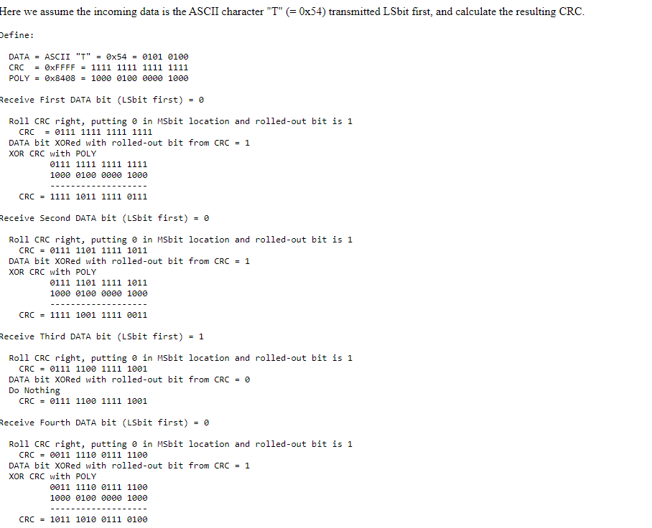

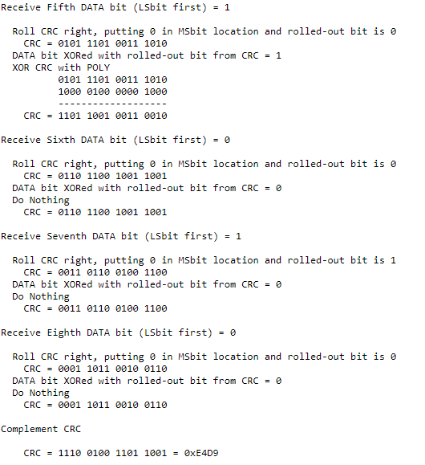

* **This process is performed for each “byte” of the packet, starting at the most significant byte and starting with the least significant bit to most significant bit.**
* **The first byte that this process will be performed on will be the most significant byte of the address field.**
* **The last byte that this process will be performed on will the least significant byte of the Info field.**
* **After performing this on the last byte, then perform one’s compliment on the current crc and that value will be the FCS field.**